**National 4/5 Modern Studies**



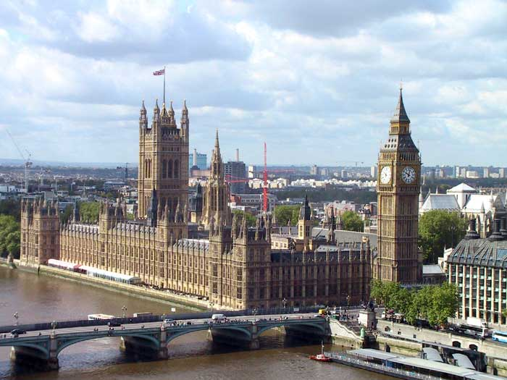

[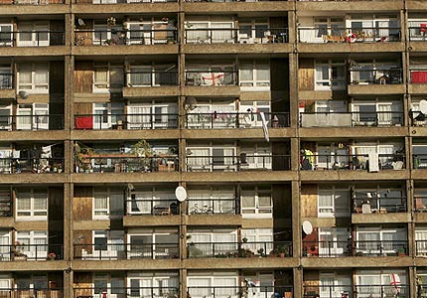](http://www.google.co.uk/url?sa=i&rct=j&q=poor+council+estate&source=images&cd=&cad=rja&docid=jPHEiPZYYm7dTM&tbnid=rVqPldmftU9PHM:&ved=0CAUQjRw&url=http://lintineqegs.wordpress.com/page/3/&ei=9SaBUbjDB66d0wW1wICIDA&psig=AFQjCNFc65aljXoNAR7fbKpsk0Qau76Jug&ust=1367504822497410)

[](http://www.google.co.uk/url?sa=i&rct=j&q=pounds&source=images&cd=&cad=rja&docid=keM3ZjELEriENM&tbnid=WwR_kWwE8_O6YM:&ved=0CAUQjRw&url=http://www.123rf.com/photo_4613140_range-of-british-pounds-coins-uk-currency.html&ei=YSeBUeKHD4qM0wX3gYGIDQ&psig=AFQjCNESy2t5lgzGFkWnM7b6dU71uLFObQ&ust=1367505104674515)

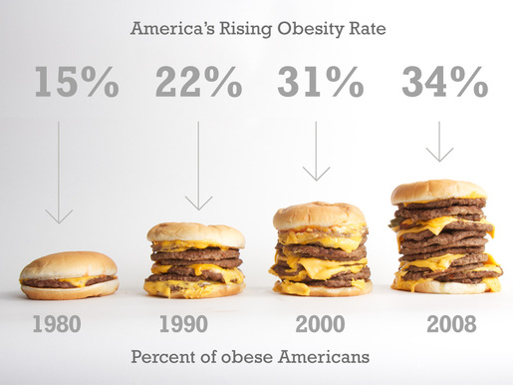****



**What will I study?**

You will study three units in this course: a UK politics unit; a UK social issues unit and, an international issues unit.

|  |  |
| --- | --- |
| **UK and Scottish**  http://www.jonathanedwards.org.uk/wordpress/wp-content/uploads/westminster-b.jpg**Politics** | **Democracy in the UK and Scotland:** This unit is a study of who represents us at the UK, Scottish and local level; how these people represent us; elections, voting and political parties; participation and, how the media influence decisions. |
| **UK Social Issues**  **C:\Users\LothianK\AppData\Local\Microsoft\Windows\Temporary Internet Files\Content.IE5\L8TIDVL1\MC910216363[1].png** | **Crime and the Law in the UK:** This unit explores why people commit crime; different types of crimes; punishments and their effectiveness; the role of the police; how crime affects communities and, the court system. |
| **C:\Users\LothianK\AppData\Local\Microsoft\Windows\Temporary Internet Files\Content.IE5\LWRCPMMR\MC900444641[1].jpgInternational Issues** | **World Power: The USA:** This unit looks at the USA as a world power; the US system of government and how far all Americans take part; ways that Americans are unequal in terms of health, crime, education and wealth; how the US Government is dealing with these problems and, the rights and responsibilities of US citizens. |

**What skills will I learn?**

National level is designed to develop a range of skills for both the courses themselves and, skills for life and work outside of school.

You will learn a wide range of knowledge relating to each topic and will be able to explain things like why people suffer inequality and how well we are represented.

There are three types of source skills: finding and showing bias or exaggeration; making and supporting decisions; coming to conclusions and backing them up with evidence.

You will also develop your research and presentation skills looking further into something you have studied.

You will also be developing lots of useful skills and abilities for life such as: confidence; independent working; problem solving; becoming interested in and understanding the world we live in; good communication; reading and writing skills and, evaluating information from places like newspapers and the internet.

**C:\Users\LothianK\AppData\Local\Microsoft\Windows\Temporary Internet Files\Content.IE5\V5J06YHD\MC900282092[1].wmfWhat will I have to do?**

You will be expected to come prepared to class and be ready to learn. You will have regular homework to hand in on time. Some of this will be larger research tasks that you will have to give time and effort to. You will be expected to cooperate in class, take part in lessons and show an interest in your work. In Modern Studies it is very important to pay attention to the news and what is happening around you. You will also have assessments to prepare for and pass. You will be asked to think about your work and plan how to improve. To do well you should be prepared to take the initiative, seek help when you need it, know what’s going on in the world and communicate with us about how you are doing on the course.

**What will we do for you?**

We are here to help you do as well as you can in National Modern Studies! Your lessons will be prepared; you will have different activities to help you learn; you will have lost of chances to discuss current events in class; you will get plenty of feedback on your work to help you improve; you will have regular opportunities to practise your skills; you will get one-to-one help; you will get help with revision and you will have one lunchtime a week to get additional help with anything from the course.



**How will I be formally assessed?**

|  |  |
| --- | --- |
| **National 4** | 1. You will have a **unit assessment** to pass for all three units. These will judged on a pass/ fail basis and will test both knowledge and skills. You will be able to re-sit them if necessary but you must pass them all to stay at this level. 2. You will also have to produce a piece of work using **your own research** on anything from the course. You will get to practise this and a lot of time to complete it but it must be your individual work to pass. You will be assessed more on skills than knowledge in this assignment. To pass you must be able to research individually, talk about your research methods, present some knowledge on the issue and, make basic conclusions about the issue. 3. There is no exam at National Four Level. |
| **National 5** | 1. You will have a **unit assessment** to pass for all three units. These will judged on a pass/ fail basis and will test both knowledge and skills. You will be able to re-sit them if necessary but you must pass them all to stay at this level. 2. You will also have to produce a written piece of work using **your own research** under timed conditions on anything from the course. You will get to practise this but it must be your individual work to pass. This makes up 25% of your mark. You will be assessed more on skills than knowledge in this assignment. To pass you must be able to research individually, evaluate your research methods, present detailed knowledge and make conclusions about the issue. 3. Finally, there is **an exam** at National Five Level. This makes up 75% of your mark. The paper lasts 1 hour 45, has 3 sections and a total of 60 marks. You will be assessed more on knowledge although skills will also be tested. You will have **a prelim** before Christmas to help prepare. |