National 4/5 History
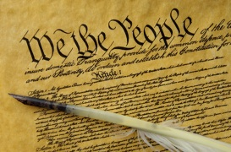

The USA
1850-1880

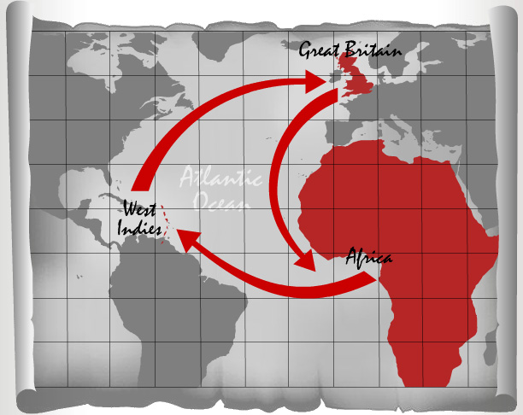
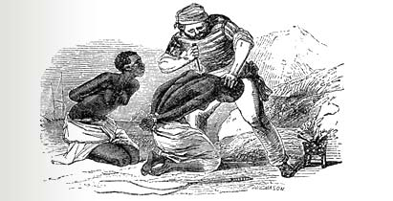
The Atlantic Slave Trade

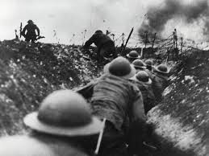
The Great War

What will I study?

You will study three units in this course: a Scottish Unit; a British unit and, a European and World unit.

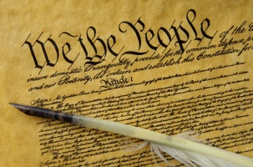  European and World unit | The USA 1850-80: This unit looks at the people who moved west in America and the impact this had; the issue of slavery; what caused the American Civil War and what happened afterwards and, the sad end to the Native American Indian way of life.
British Unit | The Atlantic Slave Trade 1770-1807: This unit explores how the slave trade was organised and the impact it had in Africa and the West Indies; the importance of the trade to Britain; the experiences of the slaves and how they resisted and, the campaigns to abolish slavery.
Scottish unit | The Era of the Great War 1910-1928: This unit is a study of the experiences of Scots in WW1; new technology used in the war and life in the trenches and, how life in Scotland changed in almost every way.

What skills will I learn?

National level is designed to develop a range of skills for both the courses themselves and, skills for life and work outside of school. You will learn a wide range of knowledge relating to each topic and will be able to explain events in terms of causes and impact. There are three types of source skills: explaining why a source might be useful for learning about a topic; comparing two sources of information and, showing how fully a source describes something from the course. You will also develop your research and presentation skills looking further into something you have studied. You will also be developing lots of useful skills and abilities for life such as: confidence; independent working; problem solving; understanding the world we live in; reading and writing; good communication and, evaluating information.

What will I have to do?

You will be expected to come prepared to class and be ready to learn. You will have regular homework to hand in on time. Some of this will be larger research tasks that you will have to give time and effort to. You will be expected to cooperate in class, take part in lessons and show an interest in your work. You will have assessments to prepare for and pass. You will also be asked to think about your work and plan how to improve. To do well you should be prepared to take the initiative, seek help when you need it and communicate with us about how you are doing on the course.

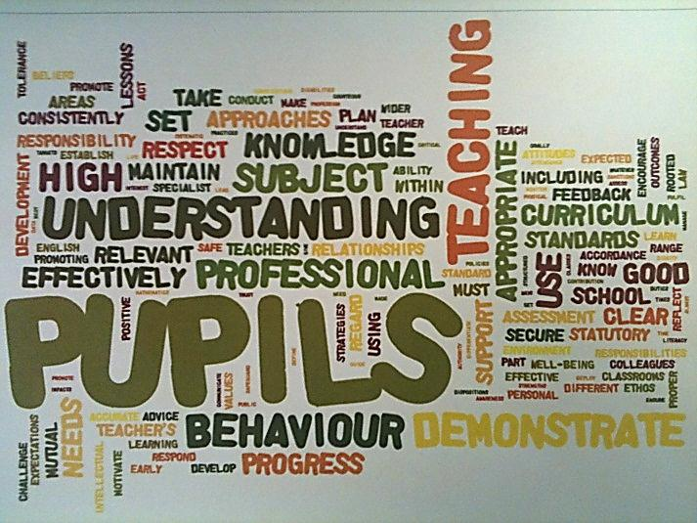
What will we do for you?

We are here to help you do as well as you can in National History! Your lessons will be prepared, you will have different activities to help you learn, you will get plenty of feedback on your work to help you improve, you will have regular opportunities to practise your skills, you will get one-to-one help, you will get help with revision and you will have one lunchtime a week to get additional help with anything from the course.

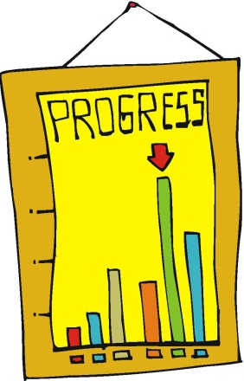

How will I be assessed?

National 4 | - You will have a unit assessment to pass for all three units. These will judged on a pass/ fail basis and will test both knowledge and skills. You will be able to re-sit them if necessary but you must pass them all to stay at this level.  - You will also have to produce a piece of work using your own research on anything from the course. You will get to practise this and a lot of time to complete it but it must be your individual work to pass. You will be assessed more on skills than knowledge in this assignment. To pass you must be able to explain some causes and basic impact of events, give some different viewpoints and try to organise your work well.  - There is no exam at National Four Level.
National 5 | - You will have a unit assessment to pass for all three units. These will judged on a pass/ fail basis and will test both knowledge and skills. You will be able to re-sit them if necessary but you must pass them all to stay at this level.  - You will also have to produce a written piece of work using your own research under timed conditions on anything from the course. You will get to practise this but it must be your individual work to pass. This makes up 25% of your mark. You will be assessed more on skills than knowledge in this assignment so to pass you must be able to explain the causes and impact of events, give viewpoints and organise your work well.  - Finally, there is an exam at National Five Level. This makes up 75% of your mark. The paper lasts 1 hour 45 minutes, has 3 sections and a total of 60 marks. You will be assessed more on knowledge although skills will also be tested. You will have a prelim to help prepare.

