Life on board

[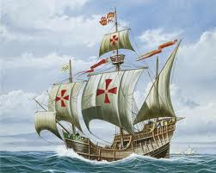](http://www.google.co.uk/url?sa=i&rct=j&q=santa+maria&source=images&cd=&cad=rja&docid=mzKP-PHfeoWekM&tbnid=k252XI1M3by0wM:&ved=0CAUQjRw&url=http://www.1zoom.net/Miscellaneous/wallpaper/202142/z224.9/&ei=TzeKUdaAF8iA0AXO1IDAAQ&bvm=bv.46226182,d.d2k&psig=AFQjCNEET9-I3uGDXmdlnwpT_toXfQw_SQ&ust=1368098998715560)The captain and the officers would have had an easier life than ordinary sailors. The sailor’s life was both **dangerous and extremely boring**! Life consisted of routine tasks which were very important for keeping the ship afloat. These tasks included scrubbing the decks, repairing sails, waterproofing the hull, pumping out the bilges and adjusting the sails. The sailors would work in shifts called watches. In between watches they would try to get as much sleep as they could.

[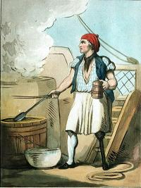](http://www.google.co.uk/url?sa=i&rct=j&q=ships+biscuits&source=images&cd=&cad=rja&docid=gP_JYtMvTBrXqM&tbnid=XgmGCbvZMrFQaM:&ved=0CAUQjRw&url=http://www.portcities.org.uk/london/server/show/ConGallery.57/Ranksin-Nelsons-navy.html&ei=ZSOKUfTNMPTu0gWK-oHICg&bvm=bv.46226182,d.d2k&psig=AFQjCNFGLxrjZvIdBjfFH1QlNqDs3C27Mw&ust=1368093892038327)The **food** was limited and of poor quality. A typical meal consisted of salt beef, pork or fish, ale and a kind of dry biscuit. Most meals were cooked by sailors that were unfit for other duties, for example if they had a disability, and out on the open deck with a type of BBQ. Kitchens below deck weren’t introduced until the 16th Century.

[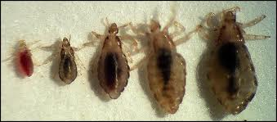](http://www.google.co.uk/url?sa=i&rct=j&q=lice&source=images&cd=&cad=rja&docid=sygn2dmi4lyuDM&tbnid=I79vqYcwLtfk8M:&ved=0CAUQjRw&url=http://www.lice-head.com/head-lice-pictures/&ei=XCSKUZeFGsqx0QWVqoHABg&bvm=bv.46226182,d.d2k&psig=AFQjCNHEvqdoGzQvWDpV_dPtYexLXJpF_Q&ust=1368094108364921)The conditions on board were very **unhygienic**. The sailors would live and work in very cramped conditions. They would sleep on deck as it was too unhealthy below deck. This meant that they were exposed to the high winds, burning sun and driving rain. Washing and toilet facilities were very limited which meant that it was hard for the men to keep clean and healthy. Their clothes would not be washed often and generally people of this time did not understand the importance of good hygiene. The sailors also had to sew their own clothes to fix them. Lice would breed in their clothes and they would get ill from food that had been chewed by rats. If one person got sick the illness easily spread.

[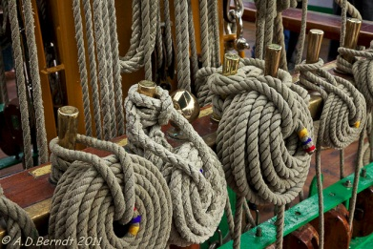](http://www.google.co.uk/url?sa=i&rct=j&q=ships+rigging&source=images&cd=&cad=rja&docid=nt3Gydw1QtDH8M&tbnid=00e24xFmVIwhTM:&ved=0CAUQjRw&url=http://www.flickr.com/photos/edinburgh_doug/5927897352/&ei=2iOKUemgGInL0AWhqICgDA&bvm=bv.46226182,d.d2k&psig=AFQjCNGr-Lx8HtcS7aPzCusAlzVklRXjsw&ust=1368094014817453)The **endless routine** was very boring for the men but also very important. The **caulker** would endlessly rub the decks with oil and pitch to keep them watertight and pump out all of the water that got into the bilges. The **boatswain**, or Bo’sun, would have to look after the ropes, sails, rigging and anchor and, make constant repairs. The **steward** would be in charge of the food and water supplies and, making sure that they had enough for the journey.

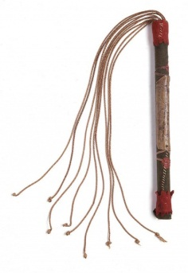

[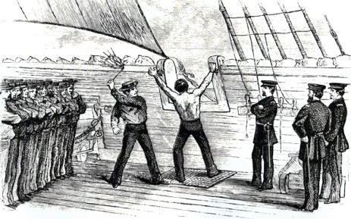](http://www.google.co.uk/url?sa=i&rct=j&q=flogging,+ship&source=images&cd=&cad=rja&docid=2l4rKgmpwAY52M&tbnid=BT8A0R4gOVIjnM:&ved=0CAUQjRw&url=http://www.poorwilliam.net/al-092810.html&ei=8TaKUZLxDYmP0AW0pIDIDw&bvm=bv.46226182,d.d2k&psig=AFQjCNHbfl1z895V-KzQJ0FJq6tjj-bVsg&ust=1368098915090843)This round of routine tasks, cramped living conditions and boredom often led the men into **trouble**. Sailors would get drunk, fight and sometimes even refuse to obey an order which is called mutiny and was a very serious offence. For minor unrest sailors would face a fine, ducked in the sea, put in irons or flogged with a ‘cat ’o’ nine tails’. For more serious offences like mutiny, they may even face the death penalty. A popular story is that sailors were made to walk the plank. However, this is another myth and they would have been hanged from the yardarm which was part of the sail. This punishment was rare as each ship needed its crew to complete the journey. The other sailors had to stand and watch each punishment and, they were harsh to act as a warning.

Activities

Knowledge and understanding

1. Explain why the sailors had such a limited diet.
2. What is the purpose of salting meat and fish?
3. What kinds of problems can a bad diet lead to?
4. Describe the unhygienic conditions that the sailors faced.
5. What kinds of problems would this lead to?
6. Choose one of the jobs on the ship. Explain why it was both boring and also extremely important.
7. Why did some sailors end up causing trouble on the ship?
8. Describe the punishments that sailors faced for causing trouble.
9. Why were these punishments so harsh?
10. Describe another myth about life at sea.
11. Why was the death penalty only used rarely?
12. Try to imagine life on board one of these ships. Which would be the **two** biggest hardships? Give reasons for your answer.

Comparing and making links

Food on board

At the beginning of a journey the steward would stock up with things like: salt beef; salt pork; salt fish; peas and beans that can be stored; ships biscuits which are hard and store better; flour; onions; garlic; oil; salt and some herbs; cheese and, butter. The sailors drank water, weak ale and ‘grog’ which was watered down rum.

1. Write down a typical meal that you would eat for dinner at home.
2. Now, write down a typical meal that the sailors would have eaten.
3. Which meal is healthier? Give reasons for your answer.
4. Now make a list of as many of the different types of food you eat in a week as you can think of. *Meat, potatoes, fruit …*
5. Give examples of **three** things that the sailors did not get much of in their diet compared to your diet.
6. Using the ingredients above create a menu of breakfast, lunch and dinner for the sailors on board a voyage of discovery. Be creative!

The Sailor’s Rest

C:\Users\LothianK\AppData\Local\Microsoft\Windows\Temporary Internet Files\Content.IE5\5XLKQ0FE\MC900329108[1].wmf Breakfast of…

Lunch of… C:\Users\LothianK\AppData\Local\Microsoft\Windows\Temporary Internet Files\Content.IE5\5XLKQ0FE\MC900112348[1].wmf

Dinner of…