**Home Front Investigation**

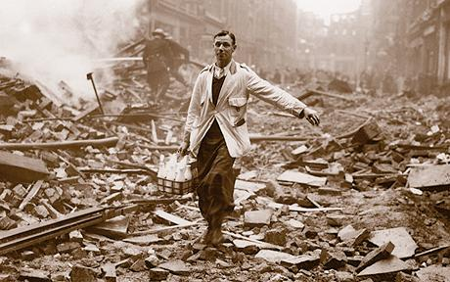You are going to carry out an investigation into life on the Home Front. You can choose what you want to investigate. You should try to follow the instructions below in order to do well.

What to include

* A title page
* An introduction
* You must include information for **3** separate headings

*You can choose any three of the options OR you can choose one of the options and study it more in-depth.*

* An explanation of why EACH of the things you have chosen was so important for the war effort
* A conclusion
* A bibliography

C:\Users\LothianK\AppData\Local\Microsoft\Windows\Temporary Internet Files\Content.IE5\W339XSRU\MC900055587[1].wmfYou should also try to…

* Include pictures, charts or drawings
* Use more than one **type of source** i.e. *books, documentary, internet, Youtube clip etc.*
* Check **spelling**
* Make an effort with **presentation**

What not to do

* Do not **copy** from the internet
* ***C:\Users\LothianK\AppData\Local\Microsoft\Windows\Temporary Internet Files\Content.IE5\5LPARX6J\MC900019332[1].wmf***Do not **copy** from other people

Presentation

* You can **type or write** the investigation

**My investigation is due**: _________________________________