Revision Sheet
Atmosphere

Global warming / Greenhouse Effect

Graph – Global temperatures.
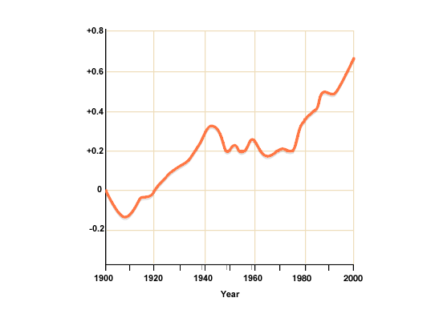
(Source: bbc.co.uk/scotland/learning/bitesize/higher/geography)

When describing the variations on the graph you should be able to:
- Describe the general trend of the graph ( does it increase/ decrease / plateaux ).
- Describe the highest and lowest points on the graph and when this happens also include the overall range in temperature (max – min temp).
- Pick out any significant changes e.g. a sharp increase and the year this happens.
- What year does the graph start to climb above the norm?
- Remember you must use figures and dates from the graph in your answer!!

Physical reasons for climate change
- Solar energy – sun spot activity can increase global temperatures..
- Volcanic eruptions – an increase in atmospheric gases given out by a large eruption can change the amount of solar radiation which reaches the earth.
- Wobble, roll and stretch – the earths orbit changes affecting the amount of insolation reaching the earth.
- Changing oceanic circulation and land masses – warm ocean currents can change or stop which shuts of a heat supply to certain parts of the globe.

Human Reasons for climate change
- Increased fossil fuel burning – increased car ownership, cheap air travel, domestic heating, rapid growth of Chinese economy.
- Deforestation – logging burning and clearing tropical rainforests increases CO2.
- Increased methane – increased rice production from paddy-fields, increased numbers of flatulent cattle, more waste disposal sites.
- Increased Nitrous Oxides – car exhausts, fertilisers and deforestation.
- CFCs – found in solvents, refrigerators and foam production.

Remember - don’t just write a list, explain each point in turn.

Consequences of Global Warming
- Rise in Sea level – melting of ice caps.
- Strengthen coastal defences – high cost!
- Major problems for low lying countries e.g. Netherlands and Bangladesh.
- Natural vegetation zones may change. E.g. spread of desertification.
- Wildlife sensitive to temperature change.
- Worst effected areas would be developing countries who rely on single cash crops for their earnings if crops fail.

