**Was Christopher Columbus a success or failure?**

Christopher Columbus wanted to set up colonies for Spain and to find riches in the Far East. He wanted to find a new route to the east by sailing west. He promised the King and Queen of Spain that he would bring back gold, spices and silks and, to bring Catholicism to the people he met.

On his **first voyage** he sailed from Spain in 1492 with three ships: the Niña; the Pinta and the Santa Maria. He discovered some islands off North America. However, he also kidnapped some of the natives to act as guides to other islands.

On his **second voyage** he discovered some islands including Jamaica. He set up the colony of Hispaniola. However, Columbus’ crew was cruel to the Indians who lived there.

On his **third voyage** Columbus discovered South America. He went back to Hispaniola and found the people who lived in the colony were short of food and ready to rebel. The King of Spain heard about it and Columbus was arrested and sent back to Spain in chains.

Columbus wanted to show the King and Queen of Spain that he was a good man. He went on a **fourth voyage**. Columbus arrived at Panama. They found some gold there and set up a trading post. The Indians who lived there did not like Columbus and his men being there. They forced them to run away.

Columbus was **disappointed** because he did not find a new route to the East. He returned to Spain in 1504. He hoped the king and queen would ask him to lead another expedition but they did not. He died in 1506, disappointed that he had not found a new route to the Far East. He had failed to fulfil his ambition and follow in the footsteps of his hero Marco Polo.

Historians say that he was not the first man to discover America because the Vikings had been there before him. The continent of America was also named after Amerigo Vespucci and not Columbus. However, he did **open up a new pathway** from the Old World (Spain, Italy, etc.) to the New (America) and changed life forever on both sides of the Atlantic Ocean.

**Was Christopher Columbus a success or failure?**

**Task –** You are going to write a short piece on Christopher Columbus and his achievements. There should be **four parts** to your writing. Use the guide below to help get you started.

1. **Introduction:** You need to start by saying who Columbus was and give some background information. You could start like this:

*Christopher Columbus was an explorer. He wanted to find riches and new land for Spain…*

1. In this **paragraph** you need to write about some things that went well for Columbus and that he could be pleased about. You could start like this:

*In some ways Columbus could be pleased with the things he did in his life. Here are some examples …..*

1. In this **paragraph** you need to write about some things that did **not** go well for Columbus and that he would **not** be pleased about. You could start like this:

*In other ways Columbus would be unhappy with the things he did in his life. Here are some examples …..*

1. **Conclusion**: In this paragraph you have to try to say what you think. Do you think Columbus did well or badly in his life? Was he a success or failure? You could start like this:

*In conclusion I think that Columbus was ___________ because…*

[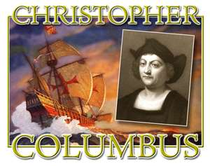](http://www.bing.com/images/search?q=christopher+columbus&view=detail&id=DDC55999BD130BFD859D21787E2359B2C1716888&first=0&qpvt=christopher+columbus&FORM=IDFRIR)

[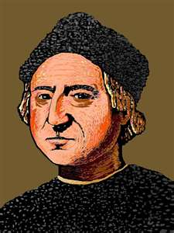](http://www.bing.com/images/search?q=christopher+columbus&view=detail&id=687DF9A074D4EC20A8A1EF464241451AD3FA3E76&first=31&FORM=IDFRIR)