Gairloch High School

“Geography is a subject which holds the key to our future”
Michael Palin
The Big Book of Geography Studies
Ideas to inspire your N5, Higher or Advanced Higher Geography Assignment.

Glaciation

General Studies
- Study a suitable area and look for evidence of glaciation.
- Study a suitable area and look for evidence of glacial erosion.
- Study a suitable area and look for evidence of glacial deposition.
- Compare and contrast two glaciated valleys in different areas.
- Compare and contrast an actual glacial valley with a textbook diagram of this.

Glacial Features
- Study a group of drumlins.
- Determine the direction of ice movement down one, or several, valleys.
- What evidence of moraine can be found in your chosen area?
- Are aretes sharper-edged and steeper on N-E facing slopes?
- Do bottoms of U-shaped valleys often contain V-shaped secondary river beds?
- Using evidence (e.g. hanging valleys, truncated spurs) estimate the shape of the original, pre-glacial valley.
- To what extent are glacial valleys U-shaped?

Corries
- Are smaller corries found at higher altitudes?
- Do larger corries have steeper back walls?
- What direction do most corries face?
- Are south-facing corries found at higher altitudes?
- What percentage of corries contain corrie lochans?
- Are lochans found mainly in smaller corries?

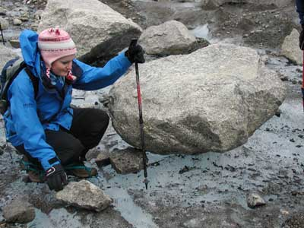
Slopes

Different Bedrocks
- Do slopes on different bedrocks have different land uses?
- Are sheep mainly found on steep or permeable slopes?
- Ae cattle mainly found on gentle or impermeable slopes?
- Is soil depth less on impermeable slopes than on similar permeable ones?
- Is there a wider range of vegetation on impermeable slopes than on permeable ones?
- Do farmers prefer impermeable slopes?
- Is there a greater range of land-use on impermeable slopes?

Different Aspects
- Do slopes with different aspects have different land uses?
- Is the vegetation on northern slopes of poorer quality?
- Is the vegetation lusher on eastern slopes?
- Is there a greater range of land-use on southern and eastern slopes?

Different Gradients
- Does slope gradient affect land-use?
- Is soil depth down concave slopes different from that down convex slopes?
- Is a greater range of activities found on gentler slopes than on steep ones?
- Do farmers prefer gentle slopes to steep ones?

Scree Slopes
- Are scree types and distribution affected by slope gradient?
- What impact do humans have on scree slopes?
- Is the amount (size and depth) of scree greater towards the bottom of a slope?

River Valleys
- Make a valley cross-section at the 3 stages of a river course. How does this compare with a diagram in a textbook?
- Compare a cross section of the upper stage of a river with a diagram of this in a textbook.
- Compare a cross section of the middle stage of a river with a diagram of this in a textbook.
- Compare a cross section of the lower stage of a river with a diagram of this in a textbook.

Soil

Slopes & Soil
- Is soil wetter at the base of a slope?
- Is soil moisture related to texture?
- Is soil deeper on gentle slopes at the bottom of valleys?
- Is soil more acidic on steeper slopes?
- Does bedrock (geology) affect soil content?
- Does humus content vary down a slope?
- Is texture related to slope angle?
- How does acid level vary down a slope?
- How does chemical content vary down a slope?

Vegetation & Soil
- Find two fields of uncultivated grass – one poor and the other good – what soil differences are there?
- Compare moorland soil with valley soil.
- Compare undisturbed land in various locations – near coast, meander etc.

Land Use & Soil
- In what way does land-use affect soil composition?
- Survey soil in various parts of a farm and relate composition to use.
- What relationship exists between types of crop and soil?
- Do all wheat fields have similar soils?
- In what way does land-use affect compaction?
- Is there a relationship between soil compaction on footpaths and the number of people using them?

Rivers

Entire River Projects
- Compare and contrast a textbook “model” of a 3-stage river course with an actual one.
- Try to locate the three stages of a chosen river by fieldwork investigation.
- How do stream characteristics vary along the river – width, depth, speed, efficiency, shape of valley, gradient?
- How does surface speed vary along a river?
- Compare surface speed down a river with gradient and cross-section.
- Does load become smoother and smaller downstream?
- Does the amount of deposition increase downstream?
- How does river-use change downstream – and why?
- Does commercial use of a river intensify downstream?
- Does recreational use of a river intensify downstream?

River Section Projects
- By investigation in the field, describe river characteristics in the upper stage.
- By investigation in the field, describe river characteristics in the middle stage.
- By investigation in the field, describe river characteristics in the lower stage.
- How does discharge change downstream?
- How does width affect speed and discharge? – study two neighbouring sections of a river – one narrow and the other wide.
- Compare a meander with a neighbouring straight stretch of a river.
- How do depth, width and speed vary along one meander?
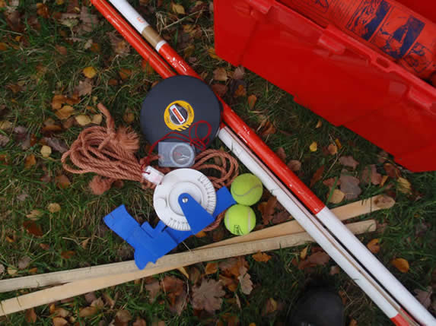
Vegetation

General Vegetation Surveys
- Is type of vegetation linked to type of soil?
- Is type of vegetation linked to type of microclimate?
- Is type of vegetation linked to altitude?
- Is type of vegetation linked to gradient (i.e. slope angle)?
- Is type of vegetation linked to position on a slope?
- Is type of vegetation linked to aspect (i.e. slope direction)?
- Visit a farm and link crop types with crop requirements.
- Select a crop (e.g. wheat) and visit as many farms as possible seeing if there are similar soil factors.
- Compare and contrast the amount and type of vegetation in suburbs and towns.
- Compare and contrast a moorland with a meadow, and try to explain the variations.

Woodland Surveys
- In a wood, is there a link between vegetation and variations in temperature distribution?
- In a wood, is there a link between vegetation and variations in drainage?
- In a wood, is there a link between vegetation and variations in soil pH?
- In a wood, is there a link between vegetation and variations in humus content?
- In a wood, is there a link between vegetation and variations in light intensity?
- Survey the distribution of a woodland’s tree types.
- Survey the distribution of a woodland’s tree ages.
- Survey the distribution of a woodland’s tree sizes.
- Survey the distribution of a woodland’s vegetation strata.
- What effect have humans had upon a chosen woodland? (e.g. trampling, planting, polluting, cutting)
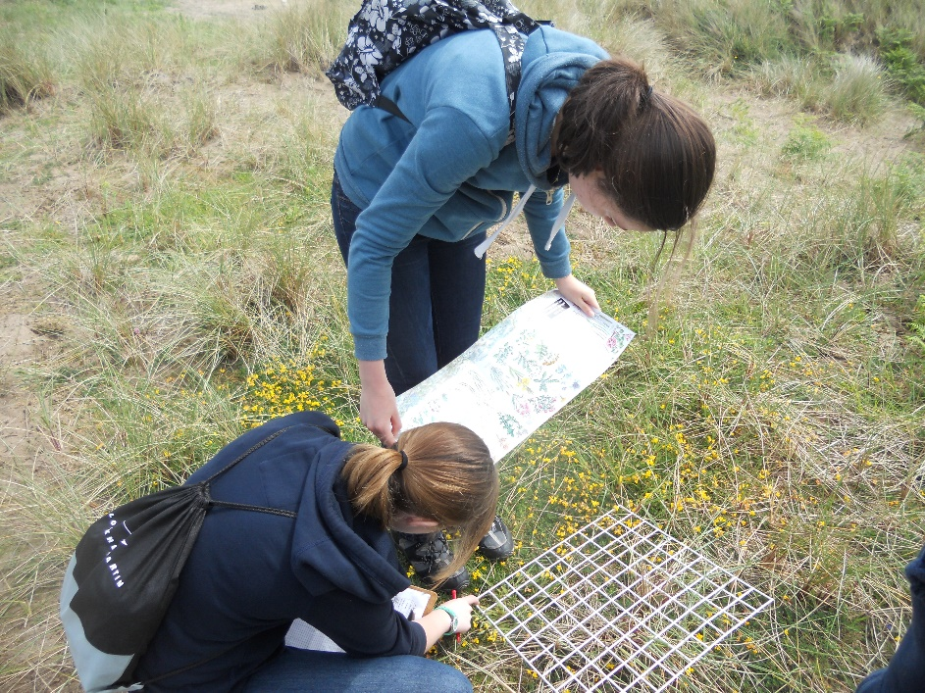
Coasts

Shorelines
- In an area of erosion, find evidence of what is causing it.
- In an area of deposition, find evidence of what is causing it.
- Study a spit and find evidence for how it was formed.
- Study a bay and find evidence of how it was formed.
- Study a headland and find evidence of how it was formed.
- How and why do cliff profiles vary along the coast?
- How and why do beach profiles vary along the coast?
- Contrast rock and beach shorelines – what features are found and how are they formed?
- Are pebbles near cliffs larger and more angular than those near the waterline?
- Measure the rate of longshore drift in one area.
- Is the effect of longshore drift constant during the year?
- Is the rate of longshore drift related to the strength and direction of wind and waves?
- Measure the rates of longshore drift in two contrasting areas and discover why there is a difference.

Wave Action
- Study wave action along a shore – what coastal features are found?
- Compare wave action in two different areas and link this with features found there.
- Is wave direction and power related to wind speed and direction?
- Comparer normal wave action and effects with those during a storm.
- Compare waves in different seasons.

General Observations
- Compare the tidal effect at two points – the distance range, the times, and the types of wave.
- How do shoreline steepness, slope, soil depth and compaction affect the formation of run-off gulleys?
- Map and measure the number and effect of all sea defences along a shoreline.
- What signs of rain run-off erosion are there on the shore?
- What evidence of pollution can be found along the shore?
- Study the trampling effects of pedestrians along a shore footpath – depth, width, compaction and use.
- Compare several paths down to the shore and relate erosion with type of use (e.g. access, recreation).

Water Cycle

Evaporation
- Is evaporation greater with increased wind speed?
- Is evaporation greater with increased temperature?
- Is evaporation greater with increased hours of sunshine?
- Is evaporation greater on south-facing slopes?
- Is evaporation lower with increased cloud cover?
- Is evaporation lower with higher relative humidity?
- Does evaporation vary with the type of nearby vegetation?
- Does evaporation vary with the amount of nearby vegetation?
- How does evaporation affect the water level of a lake or river?

Interception
- Compare interception effects in different parts of a wood.
- Does interception vary according to type of vegetation strata?
- Does interception vary according to vegetation type?
- Does interception vary according to vegetation density (i.e. light readings)?
- Does interception vary according to wind speeds?
- Does interception vary according to season?
- Does interception vary according to rainfall intensity?

Infiltration
- Is infiltration greater on shallower slopes?
- Is infiltration greater higher up a slope?
- Is infiltration less with increased soil compaction?
- Is infiltration less with increased soil moisture levels?
- Does infiltration vary with proximity to water (i.e. near lochs, ponds, rivers)?
- Does infiltration vary with the seasons?
- Does infiltration vary according to the general weather?
- Does infiltration vary with types of nearby vegetation?
- Does infiltration vary with types of bedrock?
- Does infiltration vary with land-use?
- Does infiltration vary with soil type?

General
- How does a heavy storm affect a river?
- Do different amounts of rain affect proportionately?
- Compare and contrast the effects of a storm on a large river and a small one.
- How do different sections of a river respond to a period of rain?
- How do different areas of a wood respond to rainfall?
Weather

Weather Stations
- Is there more rainfall with low barometric pressure?
- Is there less rainfall with high barometric pressure?
- Is there high wind with low pressure?
- Does ground temperature vary more than air temperature?
- Is the coast milder and wetter compared with inland?
- Is there a difference between neighbouring highland and lowland weather?
- Is there a difference between temperatures in towns and in the countryside?
- Is there a difference in rainfall on the west and east of slopes?
- Is there a difference in temperature and hours of sunshine on northern slopes compared with southern ones?
- Study a depression as it passes over a weather site.
- Study a warm or cold front as it passes over a weather site.
- In either of the above, what changes are there…
  - In cloud formation?
  - In wind speed and direction?
  - In barometric pressure?
  - In temperature?
- Compare weather changes during a depression or front with a textbook diagram of one.
- Study weather changes during a depression or front and explain their relationships.

Microclimates
- Study the microclimate of a private garden.
- Study the microclimate of a school’s grounds.
- Is the northerly aspect of a house the coolest?
- Is northern ground temperature the coldest?
- What weather changes are there during the day in a valley?
- Compare weather changes in the valley with highland or flat lowland weather nearby.
- Is the weather at the bottom of a valley more changeable than up on the slopes?
- What effect does valley weather have upon land use found there?
- What temperature changes are there across a valley during the day?
- Is there a cold, warm, cold profile up a valley slope?
- Explain the temperature profile up the valley slope.
- Is the air colder at the bottom of a valley?
- Does aspect affect the microclimate of a valley?
- Does the north facing slope tend to be colder?
- Is the north facing slope damper?
- Does altitude affect the microclimate of a valley?
- What pattern of visibility is there at the bottom of a valley during the day?
- Does wind speed increase up a valley slope?
- What effect does a wood have upon the weather of a surrounding area?
- What effect does a wood have upon the weather of a surrounding area in different seasons?
- Do conifer woods have a greater impact on the weather of the surrounding area than deciduous woods.
- What effect does a loch have upon the weather of the surrounding area?
- Is the windward shore drier than the lee shore?
- Is the lee side cooler and wetter?
- Is fog or mist associated with lochs? If so, why?
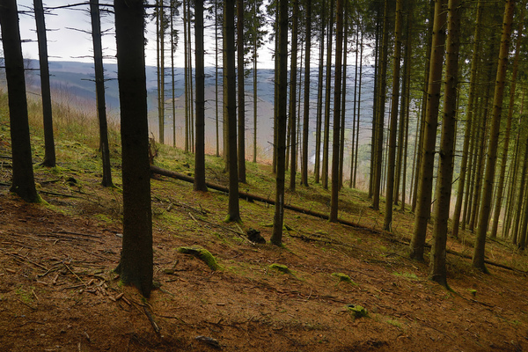

Rural Land Use

Farming
- Study several large farms. What sort, and range, of activities are found there and why?
- Study several small farms. What sort, and range, of activities are found there and why?
- Study farm sizes at different distances from a town? Are there any differences and if so, why?
- Compare land use of 15 farms in an area. What similarities and differences exist and why?
- Over a large area what types of farm exist and why?
- Compare two close farms. What differences exist and why?
- Is it true that large farms have a narrower range of activities?
- To what extent does farm practice vary with size?
- What effect does the use of machinery have upon the layout of a farm?
- Are farms producing perishable goods found closer to towns?
- To what extent does…
  - Relief affect land use on a farm?
  - Climate affect land use on a farm?
  - Geology (bedrock) affect land use on a farm?
  - Aspect affect land use on a farm?
  - Altitude affect land use on a farm?
  - Soil type and fertility affect land use on a farm?
  - Drainage affect land use on a farm?
  - Shelter from wind affect land use on a farm?
- Is more profitable land use found…
  - On level, well drained land
  - Closer to the farm house
  - Closer to towns
- Study the distribution of animals in a farm. Why are they found there?
- Study the distribution of crops in a farm. Why are they found there?
- Does agricultural land use become less intensive further away from the farm buildings?
- Does agricultural land use become less intensive further away from towns?
- Make an IPO study of a farm.
- Make a/an study of two similar farms – what differences and similarities exist and why?
  - IPO
  - Inputs
  - Processes
  - Outputs
- Do the same IPO studies as above comparing arable and stock farms.

Forestry
- Compare forestry with arable farming. What similarities and differences exist and why?
- Describe the IPOs of two forests – one coniferous and one deciduous. What differences exist and why?
- Where do the products of a chosen forest go?
- Where are the forests found and why?
- How important is a forest to local employment?
- Compare the amount of coniferous and deciduous forests in an area. Is there a pattern to this distribution and if so, why?
- Are forests only found in upland areas?

Quarries
- Where does a chosen quarry sell its goods?
- Describe the transport networks of a chosen quarry. What are they and why?
- What impact, benefits and problems does a quarry have upon the local area?
- How important is a chosen quarry to employment in the local area – both directly and indirectly?
- What attitudes do local people have towards a local quarry?

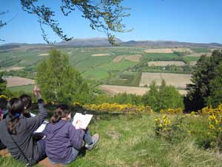

Villages

Village Population
- Compare and contrast the position of two villages.
- Studying reasons and effects, compare and contrast two villages…
  - With different aspects
  - With different reliefs
  - At different altitudes
  - One sheltered; the other exposed
  - On different geological bedrocks
  - On different qualities of soil
  - With different road densities
  - One with railways: the other not
- Does a good position lead to the growth of a large village?

Village Form
- Compare and contrast the form of two villages.
- Studying reasons and effects, compare and contrast two villages…
  - One linear: the other round
  - One compact: the other spread out
  - One formed around a central point: the other apparently shapeless
  - One on a river: the other not
- Compare and contrast a village with a “text book” village – explain the similarities and differences

Village Function
- Compare and contrast two villages with apparently different functions.
- Compare and contrast two villages, one a tourist attraction and the other not. What effects are found?
- Compare and contrast a village having round the year tourism with one having seasonal tourism. What effects do these differences have?
- Compare and contrast two villages with apparently different… What are the differences and why do they exist?
  - Employment activities
  - Age structure
  - Housing
  - Services

Village Development
- Compare and contrast two villages, one growing and the other declining.
- Compare and contrast a growing village with a declining one. What signs are there of people moving out or moving in?
- Compare and contrast a growing village with a declining one. What differences are there in...?
  - Population age structure
  - Ages of buildings
  - Services
  - Housing quality
  - Employment
  - Transport Use
  - Road Quality
- In a growing village there are more new buildings than in a declining one.
- In a growing village are there more building conversions than a declining one?
- In a growing village, how has the shape of the village changed?
- Compare and contrast two villages. What types of builds can be found and why are there differences?
- Compare and contrast two villages. What building materials have been used? Why are there any differences?

Village Population
- Study two groups of people in a village (e.g. newcomers and long stayers). What similarities and differences exist in their…
  - Employment
  - Use of transport
  - Housing quality
  - Involvement in village activities
- To what extent is a chosen village self-sufficient in…?
  - Shopping facilities
  - Health facilities
  - Education facilities
  - Generally
- Study commuters in several villagers. Are there fewer commuters further away from the main town?

Village Pollution
- Compare and contrast two streams (or different stretches of the same). What signs of pollution exist? What are their origins and what effects do they have?
- What litter patterns exist in a tourist village?
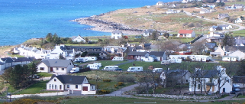
Urban Land Use
- Look through the project ideas for villages – most of these can be modified for town studies.
- Make … in two parts of a town – what differences do you note and why do they exist?
  - Urban transects
  - Urban land-use approximation surveys

Distribution
- Plot the distribution of … in a town – is there any pattern and, if so, why does it exist?
  - Residential buildings
  - The types of residential building – terraced, semi-detached, detached, bungalow, flat
  - Commercial buildings
  - The types of commercial building – shop, market, office, bank, warehouse, garage
  - Public buildings
  - The types of public building – school, church, local government office
  - Transport facilities
  - The types of transport facilities – railway, bus station, airport, port
  - Entertainment facilities
  - The types of entertainment facilities – hotel, pub, café, theatre, cinema, leisure centre, arcade
  - Open space
  - The types of open space – farmland, park,. Cemetery, water, car park
  - Unused land
  - The types of unused land – waste land, derelict building, land being developed
- Compare one or all the above in two towns – what differences exist and why?

Site, situation and shape
- Choose a town – how has the site affected its shape and growth?
- How has relief affected the shape and development of a town on a slope?
- How has flooding or its threat affected the shape and development of a town facing this problem?
- Choose a town with … - what residential building patterns are found?
  - Declining heavy industry
  - Growing modern industry
- Compare age of housing with street patterns.
- Are Victorian houses mainly found in grid shaped patterns?
- Are recent houses build in crescents and cul-de-sacs?
- Compare a town with an urban model. What evidence is there of…
  - Similarities and differences – why?
  - An upper-middle class zone on the west side?
  - Lower-middle class zones on the SW and NW?
  - Working class zones on the NE and SE sides?
  - Industry and slums on the east side?

Function
- Compare two towns - …. What differences exist and why?
  - One a market town, the other not
  - One a tourist town, the other not
- What is the zone of influence of a market town?
- In a market town, where do the shoppers come from?
- In a market town, where do the sellers come from?
- Does a large market have a greater zone of influence over a smaller market?
- Find a town with new industrial estates – how has their presence affected the shape of the town?
- Take one type of… and plot all instances of it through a town – is there a pattern and, if so, why does it exist?
  - Shop
  - Services

Hinterland
- Delimit the …. Hinterland of a town.
  - Average
  - Shopping
  - Visitor
  - Delivery area – department store, furniture store, laundry, local newspaper
  - Professional services – bank, vet, doctor, dentist, solicitor, optician, estate agent, travel agent
  - Membership – sports club, social club, societies
  - Educational – school, college, library
  - Employment
  - Public services – police, ambulance, fire station, library, hospital
- What effect does… have upon the hinterland of a town? [average or individual hinterland]
  - Relief
  - Rivers
  - Road networks
  - Neighbouring towns
- Compare the hinterlands of two similar settlements – what similarities and differences can be found – and why?
- Do people father away from the town travel more rarely into it?
Central Business District (CBD)
- Plot the CBD of a town using all available features.
- What pattern of … exists in a CBD and why?
  - Building heights
  - Pedestrian densities
  - Rates
  - Quality of shops and services
  - Shop frontage
  - First floor usage
- Compare a CBD with a textbook “model” – what similarities and differences exist and why?
- Are certain… found in clusters in a CBD – if so, which ones, and why do they do this?
  - Shops
  - Services
- Choose any type of … - plot it throughout the CBD – what pattern exists and why?
  - Shop
  - Office
  - Personal service
- What evidence is there of shops near the CBD trying to increase their frontage?
- Is there a relationship between the height of buildings in the CBD and their rateable index?
- Do towns with larger CBDs have larger hinterlands – choose two towns of different sizes?
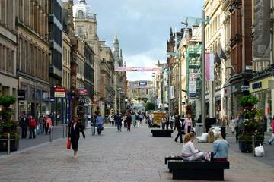
Residential Land Use

Surveys through town
- How does housing … change from the centre of a town to the edges?
  - Type
  - Condition
  - Environment
- Does … from the centre of a town to the edges?
  - The amount of modern housing increase
  - Housing density decrease
  - The size of garden increase
  - The quality of housing increase
  - The price of houses increase
  - The availability of garages increase
  - The number of people with high incomes increase

Area Surveys
- Compare the presence of … with house types and quality
  - Alarm boxes
  - Neighbourhood watch schemes
- Obtain police maps of local break-ins – how does this compare with …?
  - House type and quality
  - The presence of alarm boxes
  - The presence of neighbourhood watch schemes
- Plot change of use in a town – where houses have been converted into offices. Is there any pattern?

Estates
- Survey a housing estate – assess its quality, and compare this with …
  - Its reputation in the local area.
  - The type of people who live there
- Survey several housing estates …
  - What similarities and differences exist, and why?
  - And the people who live there – what similarities and differences exist, and why?
- Are … housing estates found farther away from the centre of town?
  - Better
  - More expensive

Commercial Land Use

Retail
Most of these projects can be made more advanced by comparing the features with those of another town. Find similarities and differences and explain them.
- Choose particular types of shop through a town. Comment upon their presdence and distribution.
- Is it true that certain shops tend to cluster together? If so, explain why?
- Compare similar types of shop. How do customer counts vary with each shop’s position in a town?
- Is there any link between pedestrian density and type of shop?
- Plot the presence of boarded-up shops through a town. Comment upon their distribution – is there a pattern and, if so, what and why?
- Identify the retail groups through a town.
- Plot the position of Group 1 shopping areas in a town - what distribution patterns exist, and why?
  - Do the same for each of Groups 2, 3, 4 and 5.
- In a Group 1 retail area of a town – comment upon the presence and distribution of a specific types of shop there.
  - Do the same for each of Groups 2, 3, 4 and 5.
- Compare the site quality of each retail group in a town – what similarities and differences exist and why?
- Comment upon the site quality of Group 1 shops found in a town. Explain similarities and differences.
  - Do the same for each of Groups 2, 3, 4 and 5.
- Compare the catchment areas of each retail group in a town – what similarities and differences exist and why?
- In a chosen town, find a Group 1 area. Identify its catchment area and make comments.
  - Do the same for each of Groups 2, 3, 4 and 5.
- How does … compare with group type?
  - Volume of usage
  - Pedestrian movement
  - Site quality
  - Frequency of usage (how often used)
- Compare shopping site quality across all groups in a town. Explain similarities and differences.
- Identify the shopping hierarchy of a town. Comment upon presence and distribution.
- In a chosen town, find a Level 1 area. Identify its catchment area and make comments upon it.
  - Do the same for each of Groups 2, 3, 4 and 5.

Offices
- Plot the distribution of … through a town. What pattern exists, and why?
  - Offices
  - Public offices
  - Business offices
  - Professional offices
  - Industrial offices
- Do some offices cluster more than others? If so, which ones and why?
- Survey office site quality through a town. What pattern exists and why?
- Identify the catchment area of … through a town.
  - Offices
  - Public offices
  - Business offices
  - Professional offices
  - Industrial offices

Sports
You can do these comparisons for multiple and single facilities, too.
- What distribution of … facilities exist in a town? What pattern can you find – is there an explanation?
  - Public sports
  - Private sports
- Identify the catchment area of … sports facilities in a town.
  - Different types of
  - Public
  - Private
- Compare site quality with the position of sport facilities in a town.
- Compare site quality with the type of sports facilities in a town.

Entertainment
Same as for sports – but the comparisons are (1) public compared with private, and (2) spectator with participator.

Garages and hotels
- In a large town, does … father away from the centre?
  - The quality of garages/hotels deteriorate
  - The cost (charges) of garages/hotels lessen
- In a large town, how is the quality of garages/hotels related to the volume of passing traffic?
- Compare the distribution of garages and service stations through a large town – what patterns exist and why?

Industrial Land Use

Single Industries
- Investigate a single large industry.
- Investigate a single large industry and identify…
  - The reasons for its siting.
  - Its impact on the local area.
  - Its impact on employment in the local area.
  - Its effect on other businesses – e.g. dependency
- What influence … upon the position of a factory?
  - Has access to market
  - Have transport networks

Industry in a town
- Survey the distribution of industry in a small town.
- What evidence of industrial decay is there in a town?
- What evidence of industrial growth is there in a town?
- Compare a new industrial site with an old one – what differences exist and why?
- Compare two towns – what similarities and differences are found in the type and distribution of industries?
- Compare two contrasting industries – what similarities and differences exist and why?
- What evidence of pollution is there in a town?
- Choose one type of pollution and plot its distribution through a town, explaining its existence.

Industrial Estates
- Investigate an industrial estate.
- For a chosen industry on an industrial estate, …
  - Why did it choose to be sited there?
  - What general benefits are gained by being there?
  - What benefits are gained by having industrial neighbours?
  - What transport benefit is gained by being there?
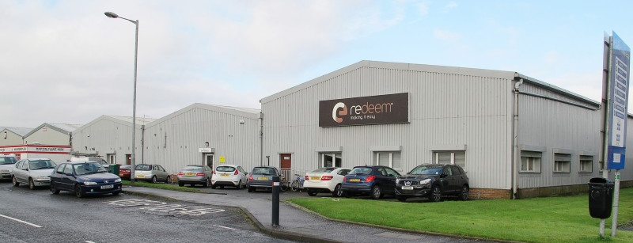
Recreational Land Use

General Studies
- Compare two different types of town (heavy industry & light; residential & industrial, tourist & commuter). What differences and similarities in … exist, and why?
  - Sporting facilities
  - Entertainment facilities
  - Clubs and societies
- To what extent do people use recreational facilities nearest their homes?
- At recreation sites, do people cluster near attractions?
- Is there any relationship between the … of recreational facilities and the size of a town?
  - Types
  - Range/quality
- Study a community’s holiday preferences.
- Compare two contrasting communities – what similarities and differences are there in their types of holiday?

Open Space
Open space means land to which the public has free access.
- Study the distribution and use of open space in a town.
- Measure and plot the catchment area of outdoor recreational facilities in your chosen area of study.
- Construct and study a hierarchy of open space in a town.
- Is there a wider range of activities in open spaces near the centre of a town?
- Is there any relationship between open space (size and range) and nearness to residential land?
- Compare and contrast the size and distribution of parks with playgrounds around a large town.
- Assess the potential of outdoor recreational facilities found in an area.
- What amenities does a rural area have for outdoor recreation?
- What differences do rural and urban areas have in outdoor entertainment facilities?

Entertainment and Societies
- Study the types of entertainment in a town. What pattern exists and why?
- Compare two towns - … - what differences in entertainment or sports facilities are there and why?
  - One large; the other small
  - One residential; the other with heavy industry.
- Study the presence and distribution of societies in a town.

Tourism
- What impact has tourism had on an area?
- Study the distribution of … in a tourism town – how is their type and distribution affected by tourism?
  - Shops
  - Entertainment
- Study the types of tourist attraction in a tourist town – how are they designed to attract tourists?
- Compare & contrast winter and summer in a tourist town.

Sports Centres
- Study a major sporting complex.
- Assess the attraction potential of a sports complex.
- How busy are the different facilities in a sports centre?
- Measure and plot the catchment area of a sports complex.
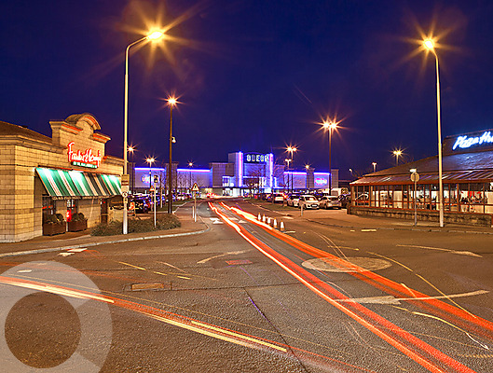
Transport

Route Networks
- Study … - what similarities and differences exist and why?
  - Route networks of two areas
  - Route networks of an urban area and a rural area
  - The route networks of a hilly region and a flat one
  - Rail networks of two large counties
- How is the route network of an area related to the …
  - Number of people living there?
  - Size of the villages and towns found there?

Traffic Flows
- Study traffic flow … - what factors influence any differences of flow?
  - Through the day at a particular point in a town
  - Through the week at a particular point in a town
  - At different times of the year at a particular point in a town
  - Through the day along the main road through a town
  - Through the week along the main road through a town
- How many people travel in and out of a town – and using what transport?
- Where do visiting vehicles come from?
- Is there any link between purpose of visit and distance travelled?
How does weather affect transport flow through a town?
- Find areas of traffic hold-ups in a town – why do they occur?
- Study the congestion through a town – why does it exist at the trouble spots?
- Find out accident statistics from the local council. Is there any relationship between accident spots and …
  - Traffic flow?
  - Congestion points?
- How long do cars tend to stay parked in a town?
- Is there any connection between time parked and purpose of visit?
- Assess the distribution, quality and usage of car parking within a town.
- How adequate are a town’s car parking facilities?
- Do different types of town have different types of parking facility?
- Construct a hierarchy of car parking facilities through a town – if so, what and why?

Public Transport
- Compare the time it takes to make journeys using different forms of transport.
- Compare bus services in two different areas.
- Plot the provision of bus stops through a town – is there any pattern, and if so what and why?
- How does bus service quality change as you move farther away from a town?
- Study the purposes people give for making their bus journeys?
- Use the index of sinuosity to compare village bus routes with town bus routes.
- Compare train networks in different parts of the country.
- Compare local train networks with intercity ones.
- Compare local train networks with intercity ones – what reasons do people give for using them?

Alterations
- What effect has a new … upon traffic flow through a town?
  - By-pass
  - Roundabout
  - Traffic light system

Terminus Studies
- Study an airport terminus.
- Compare and contrast two airport terminuses – one large; the other small.
- Do the same for ports, bus stations and rail stations.
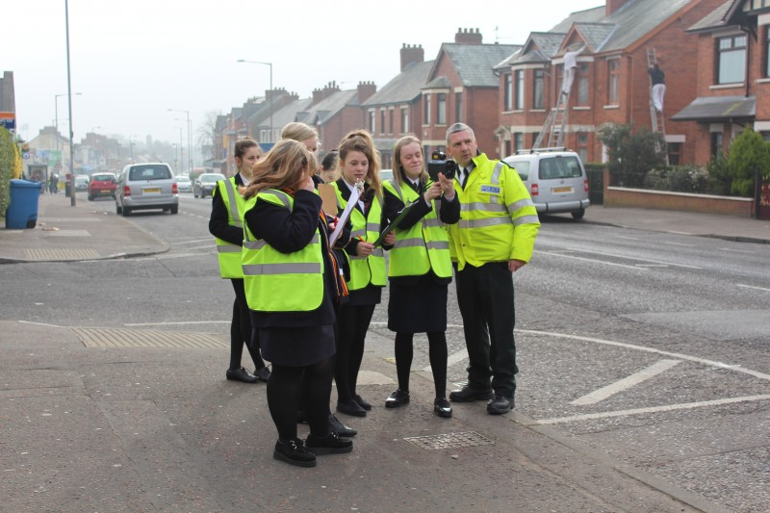
Population

Structure
- Make a population structure of a village.
- Make population surveys of two contrasting urban areas.
- When you …, what differences in population structure do you find and why do they exist?
  - Make a population survey of two villages
  - Compare a village with a town
  - Compare two housing estates – one private; the other council
  - Compare population pyramids in two villages; one growing, the other declining
- Do people in villages near towns … than those in villages farther away?
  - Stay there for shorter lengths of time
  - Tend to be younger, on average
  - Tend to be within a wider age range
- Do close friends usually live close to each other?

Movements
- What means of transport are used for travelling to school/work – is there a pattern of distribution & type?
- Study the catchment area of a school.
- Study distances and means of travel to work in two contrasting areas.
- Is there any relationship between … and the type of employment?
  - Distance travelled to work
  - Types of holiday taken
- Is there any relationship between … and the house prices?
  - Distance travelled to work
  - Types of holiday taken
- Are people who move the greatest distances the most educated?
- Do most people move house only short distances?
